# **[Demo 3: How to use Arduino ESP32 to read temperature/humidity from DHT11/DHT22](http://www.iotsharing.com/2017/05/how-to-arduino-esp32-dht11-dht22-temperature-humidity-sensor.html)**

**1.Introduction**  
The sensor module DHT11/DHT22 is used for measuring temperature/humidity. In this tutorial, we will learn **how to use Arduino ESP32 to communicate with DHT11/DHT22**(this can also be applied for DHT11) to read value of temperature and humidity.

**2. Hardware**  
Connect the pins of ESP32 to the pins of DHT22:  
[ESP32 IO14 - DHT22 DATA]  
[ESP32 3.3V - DHT22 VCC]  
[ESP32 GND - DHT22 GND]  
or follow the picture below to connect:

[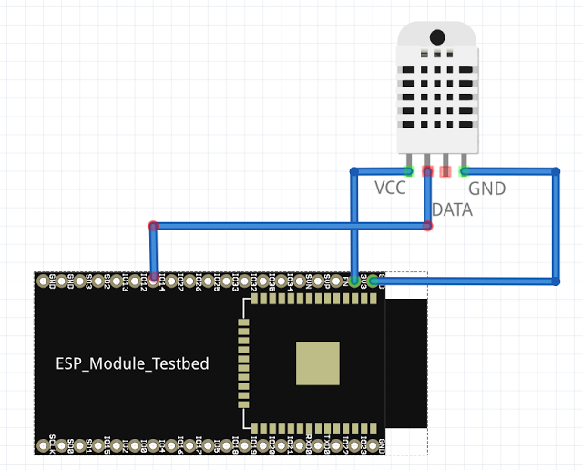](https://1.bp.blogspot.com/-3QTaDCwUoc8/WRm-oMVwaDI/AAAAAAAADz4/tVJlnmLmEVgTA0OPONRsgnvOS5LSVQzDACLcB/s1600/led4.png)

**Figure: Connection between ESP32 and DHT22**

**3. Software**  
We will use the DHT22 library sensor which is supplied by Adafruit. You can download it here:  
<https://github.com/adafruit/DHT-sensor-library/archive/master.zip>  
After downloading, unzip it and copy unzipped folder to libraries folder under Arduino folder:**[C:/Users/[YOUR_USER_NAME]/Documents/Arduino/libraries](https://www.blogger.com/null)**  
**Note:**If you already opened Arduino IDE, you need to restart Arduino IDE to get effect.  
The library supplied some functions so that you can use them to read the data from DHT22 such as:

* **readHumidity()**: to read humidity from sensor
* **readTemperature(bool flag)**: If argument flag is true then the temperature read from sensor is Fahrenheit value. If argument flag is false then the temperature read from sensor is Celsius value.

In order to use these function you must create an instance (variable) type **DHT**. E.g.: DHT dht(DHTPIN, DHTTYPE) . This will create an instance of DHT with 2 inputs (this is C++ constructor) are DHTPIN (the pin of ESP32 which connect to Data pin of DHT22) and DHTTYPE (this is DHT sensor type (DHT11 or DHT22))  
Since the sensor is slow, so we need a delay (about 2 seconds) between measurements.

Now create a Arduino project and save it as esp32dht22. Here is the code:

|  |
| --- |
| #include "DHT.h"  //here we use pin IO14 of ESP32 to read data  #define DHTPIN 14  //our sensor is DHT22 type  #define DHTTYPE DHT22  //create an instance of DHT sensor  DHT dht(DHTPIN, DHTTYPE);  void setup() {  Serial.begin(115200);  Serial.println("DHT22 sensor!");  //call begin to start sensor  dht.begin();  }  void loop() {  //use the functions which are supplied by library.  float h = dht.readHumidity();  // Read temperature as Celsius (the default)  float t = dht.readTemperature();  // Check if any reads failed and exit early (to try again).  if (isnan(h) || isnan(t)) {  Serial.println("Failed to read from DHT sensor!");  return;  }  // print the result to Terminal  Serial.print("Humidity: ");  Serial.print(h);  Serial.print(" %\t");  Serial.print("Temperature: ");  Serial.print(t);  Serial.println(" *C ");  //we delay a little bit for next read  delay(2000);  } |

**4. Result**

[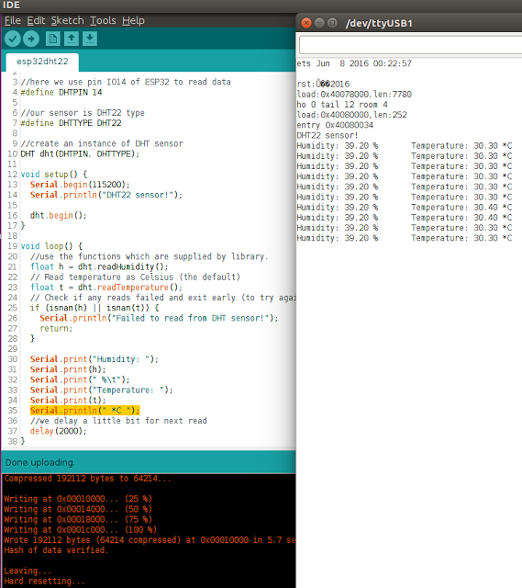](https://2.bp.blogspot.com/-rP74GLyN1-4/WRnAMZidOtI/AAAAAAAADz8/qeciiMwp9gscZIpivsA35uRI-k8xyf-0ACLcB/s1600/led5.png)

**Figure: output of DHT22**